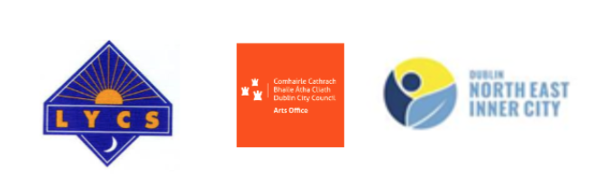



A Unique Opportunity for an Artist in Residence in a Community Development Organisation.

If you are an artist with an interest in Community Arts Development and participatory learning this residency may be for you.

INTRODUCTION
In 2022 the Lourdes Youth and Community Services (LYCS), The Community Arts Programme of the Northeast Inner City and the Dublin City Council Arts Office aim to commission and work with an experienced artist to deliver a Community Arts Residency in Dublin 1. This residency will be an opportunity for an Artist to work with some of the residents of Dublin 1 over 22 weeks in a developmental process that will be based within LYCS and will be actively supported by all three partner organisations. LYCS is the residency host and as such will be the lead contact and liaison.

The Community Artist in Residence role will include working with a variety of adult groups as we begin to establish artistic practice as a cornerstone in Dublin’s North East Inner City, Lourdes Youth & Community Services (LYCS). LYCS is a community-based education, training, and development project. From a Community Crèche to an Adult Education Programme, the organisation works with people from 6 months to older age.

Through all our programmes, we are concerned with giving our participants the opportunity to become involved in their own development and the development of their community. The North East Inner City is a vibrant and diverse place. The areas within its border include Sean MacDermott Street, Summerhill, Ballybough, Mountjoy Square and Sherriff Street – to name a few. LYCS works with participants from all parts of this community.

HOW THE RESIDENCY WILL BE STRUCTURED:
· The Community Arts Residency will take place over two phases of 22 weeks in 2022.
· The artist will be based within LYCS’ Adult Education Programme, while also having the opportunity to move in and out of other programmes – particularly the Youth Work Programme.
· Where appropriate the Residency Artist and the groups that he/she will be working with, will access the Lab Gallery and Rehearsal spaces.

THE RESIDENCY AWARD WILL CONSIST OF THE FOLLOWING:
· A €10,000 bursary for the artist over 22 weeks.
· Mentorship and support from an Advisory panel which is comprised of the following individuals (Martin McConigley, Adult Education Coordinator LYCS, Irma Grothuis Community Arts Coordinator NEIC and Liz Coman, Assistant Arts Officer, DCC)

APPLICATIONS
Enquiries and completed proposals should be submitted to: Martin McConigley, Adult Education Coordinator LYCS, martin.mcconigley@lycs.ie; (identifying the subject matter as Community Artist in Residence).
Applicants are invited to submit a CV and short proposal (2 A4 pages max.) providing a brief history and accessible links to their work, identifying the principles of their practice to date and broadly outlining their idea or starting point for creating an accessible residency that can be delivered within the context of Lourdes Youth and Community Services.
Suitable applications will be shortlisted by the Advisory Panel and will be invited to meet the Advisory Group on March 10th. Applicants will be shortlisted under the following criteria.
The ability demonstrated by the candidate in their application to meet the residency objectives.
· The understanding demonstrated by the candidate in their application of the residency’s values.
· The experience demonstrated by the candidate in their application of working with groups within the context of community.

IMPORTANT DATES:
· The deadline for the submission of proposals is 12 Noon on Friday February 18th.
· Shortlisted candidates will be asked to meet with representatives of the Community Arts Residency Team in the Lab Gallery on the afternoon of Thursday 10th March to discuss their proposal in greater detail.

The Artist in Residence is supported by LYCS, the Community Arts Programme of the North East Inner City and Dublin City Council Arts Office.

