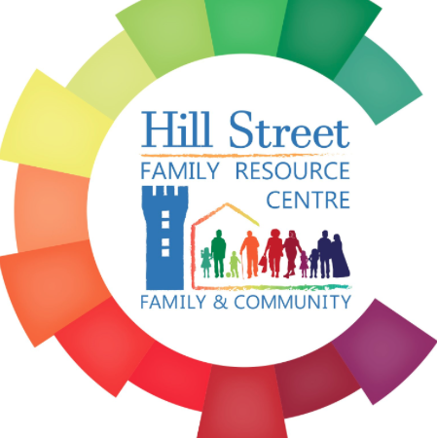
Parent Support
Circle of Security
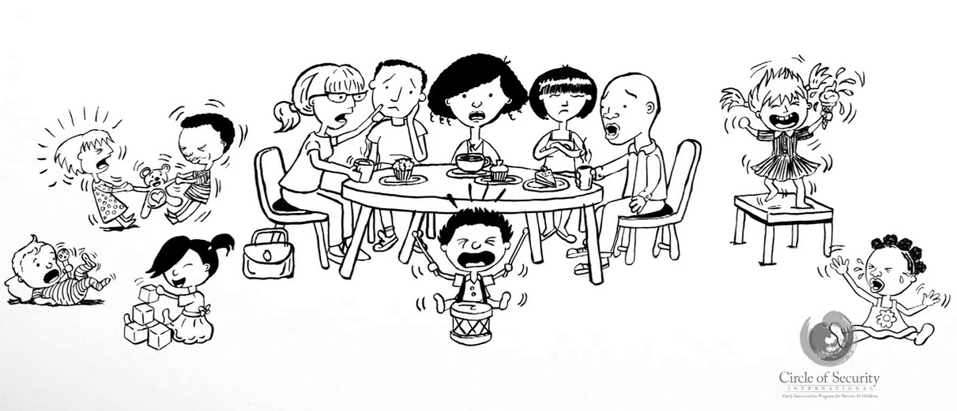
__________________________________________________________
Do you ever wonder why your child behaves like this?
Ever wonder why they don’t listen?
We can offer this training to you!

_________________________________________________________
The Circle of Security® Parenting program™ is based on decades of research on supporting and strengthening secure parent-child relationships. Studies have shown that children’s first relationships impact all areas of cognitive, social, emotional, and physical development.
In this course you will learn to...
♦ Experience more love, cooperation, and joy with your child
♦ Feel confident in your ability to be successful with your child
♦ Determine what your child needs in the moment
♦ Help your child develop self-confidence
♦ Assist your child in creating positive relationships with others
♦ Teach your child to balance their emotions and behaviour
Training Location / Dates:
When: Thursday 3rd of February 2022
Thursday morning’s 9.30am – 11.30 am for 10 sessions
€25 contribution for 10 weeks
Limited childcare places available in centre €3 per session
Call Hill Street FRC on (01) 8746810 to book your place
Course may be offered in Centre or on line dependent on current government guidelines and restrictions on groups sizes and locations.

how

