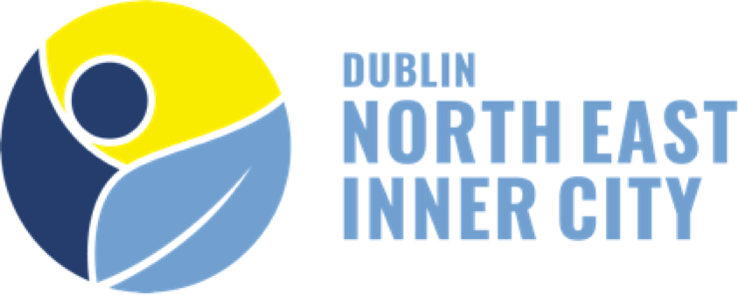

THE NEIC PEOPLE, PLANET AND PLACE INITIATIVE
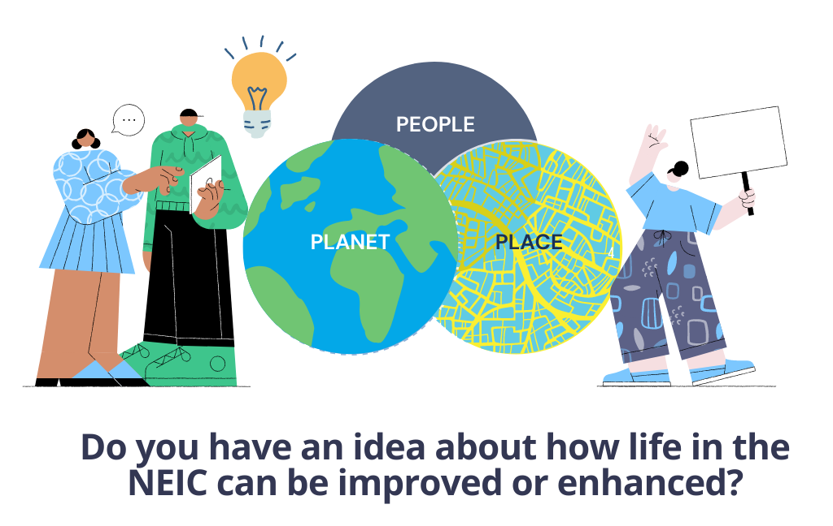

Do you have an idea about how we can make the North East Inner City a better, more liveable and sustainable place for everyone who lives, works and/or visits here? Are there projects or solutions you think have the potential to make a real difference if supported?

The NEIC Programme Office is launching its NEIC People, Planet and Place Initiative. This is a crowdsourcing campaign aimed at giving local residents, community-based groups, residents associations, social economy organisations and local businesses from the area the opportunity to share their ideas, and to communicate what kinds of training and support they would need to access, if selected, to help bring them to life.

This call is designed around three themes deemed strategically important to advancing the sustainable development priorities of the NEIC. These are:

- People (e.g. ​​improving the lives of socially excluded and marginalised communities, groups and/or individuals in the NEIC),
- Planet (e.g. greening and biodiversity, sustainability, circular economy and just transition-related projects that benefit the NEIC) and
- Place (e.g. local place-based proposals to enhance and improve the physical environment of the NEIC, such as proposals for street art and parklets).

Theme 1: People

Submissions for ideas are invited under this theme which can benefit the people and communities of the NEIC. Proposals are particularly welcome that reflect co-design methodologies (i.e. designing solutions with and not just for key users / target beneficiaries), and which look to empower target beneficiaries and users, and which look for creative ways to improve their health, wellbeing, socio-economic and/or employment outcomes for socially excluded, marginalised and/or underserved groups and individuals in the NEIC area.

We particularly welcome ideas that focus on (but are not limited to) better serving the needs of one or more of the following target groups:
- Communities of migrants / refugees / asylum seekers and newcomers to the NEIC;
- People in custody, Probationers & those living in our community with historical criminal convictions;
- People dealing with drugs and/or alcohol addiction;
- Young people living in the area;
- Young adults and long-term unemployed;
Ideas are particularly welcome from representatives of any of the communities or groups referred to above.

Theme 2: Planet

Under this theme, ideas for small scale environmental projects are invited which promote sustainable development at the local level and which have the potential to create environmental benefits for those living in the NEIC. Examples of ideas could be those that support and complement national environmental and circular economy policies, and which aim to improve outcomes for Waste Reduction, Biodiversity, Climate Change, Air, Water and Sustainable Development.

We particularly welcome ideas which focus on one or more of the topics below:
- Environmental Training, Education and Awareness-Raising Initiatives;
- Green Skills and training proposals;
- Waste reduction strategies (e.g. food waste, plastic waste, etc.);
- Development of Community/Local Areas to support Pollinators and Biodiversity (e.g. insect motels, bird or bat boxes or insect motels)*;
- Circular Economy initiatives (e.g. Repair, Reuse, Recycling and Upcycling proposals for products / materials and other proposals with potential to make significant waste and/or GHG reduction);
- Composting and Rainwater Harvesting proposals*;
- Proposals aimed at raising environmental education, awareness and performance for local food businesses in the NEIC;

Theme 3: Place
Under this thematic priority, ideas are invited that enhance the attractiveness of the local area, and which promote the NEIC as a place that people want to live, work, play, learn and relax in.

Examples of ideas we welcome under this call include:
- Creating vertical green walls or parklets;
- Planting window boxes, hanging baskets and outdoor areas (with pollinator friendly or edible plants)*;
- Urban community gardens and/or allotments;
- Arts, cultural and multidisciplinary initiatives, including street art, murals;
- Pop-up workshops or events**;
- Education and awareness raising initiatives about the history and heritage of the NEIC;
- Proposals to improve/reimagine the public realm***;
- Proposals to improve/enhance small business and/or community premises and buildings in the NEIC***;

How it works?

Step 1. Submitting your idea
Anyone who lives or works in the NEIC is eligible to apply up to the deadline of March 4th 2022. Applications can be made by filling out our online application form.
👉Click here to submit your idea (and use the application form to select which of the three themes you are applying to).

Step 2. Review and shortlisting of ideas submitted
Between March and April, the NEIC Programme Office, and our appointed independent panel of evaluators, will initiate a review of all ideas submitted. Based on the evaluation criteria below, the strongest potential ideas will be selected.

Step 3. Successful applicants contacted
Successful applicants will be contacted to discuss their ideas, and any training and supports needs the NEIC Programme Office may be able to offer. At this point, a representative of the NEIC Programme Office may set up a 1-to-1 call with you to discuss setting up an action plan for your idea, and you may be requested to sign and return a Letter of Commitment to confirm you wish to initiate a project under this Initiative.

Evaluation Criteria
Table 1 – Evaluation criteria
Criteria Marks | Marks
Clear alignment with the goals and objectives of the idea with one of the initiative’s thematic areas (i.e. People / Planet / Place) | 20%
The concept for the idea is well-defined, and there is a clear explanation for how it could work if selected | 20%
The idea presents real potential to create impact for the NEIC if selected | 20%
The idea proposer demonstrates they have the passion and capability to make the idea happen | 20%
The idea demonstrates a commitment to collaboration and partnership, including with other organisations/groups within the NEIC, as well as value for money (if project costs are specified) | 10%
NGO/Voluntary/Community/Social Enterprise Bonus | 10%

What supports are available?

- Non-financial supports may be offered to successful applicants including mentoring / coaching / access to professional advice, social impact measurement, etc.
- A limited number of high-potential applicants may be able to access financial assistance to help deliver their ideas.

