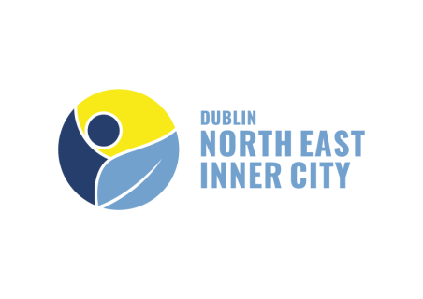

North East Inner City Initiative - Community Grant Scheme 2023

APPLICATION FORM

The theme for the 2023 Community Grants Scheme is the physical realm / environment / streetscape improvements and it will focus on providing financial assistance to residents, voluntary groups, and clubs across the community and voluntary sector who wish to implement projects of this nature.

Please ensure you have read the Scheme Guidelines and completed this form in full before submitting your application. Should you require any assistance with completing the form please contact the NEIC Programme Office neic@dublincity.ie Ph: 01-222 6604

SECTION 1 - APPLICANT DETAILS:

Organisation / Group Name

Contact Person
Email Address (which will be used for correspondence)
Phone No.
Website
Postal Address
Registered Charity Number (if applicable)
Tax Reference Number (if applicable)
Tax Clearance Access Number (if applicable)
Please provide a brief overview of your Organisation/ Group and describe its day to day activities (Maximum 100 words):

What is your Organisation/Group structure i.e (Company Limited by Guarantee, Co-operative, Voluntary, Constitution, Charity, Trust or other). Please specify:

How does your Organisation/Group currently fund day to day operation and activities?

SECTION 2 – DETAILS OF PROJECT/PURCHASE

Please provide a description of the proposed project/ purchase
Nature of the proposed spending: | Cost (inclusive of VAT, where applicable)
Please include with your application a written quote or a print-out from a supplier website as evidence of cost.
Please explain the need for the proposed project/purchase of equipment, the section of the NEIC community your service benefits (e.g children/families/older people/ people with disabilities /new communities) approximate number of people who will benefit and how often it will be in use:
Please provide details of the physical locality within the NEIC community your service benefits:

If successful, when will the equipment be purchased or the proposed project begin?

Have you applied to other agencies for a portion of the funding: Y/N

Name of Funder:

% of costs applied for:

What contingency plans have you in place should one of the applications be unsuccessful in getting the funding?

Please provide details of your capacity to deliver this project (e.g. Previous experience)

APPLICANT STATEMENT
(Must be signed by the Chairperson, Secretary, Treasurer or other authorised representative of the organisation making the application)

I confirm that I have read the Scheme guidelines, completed all relevant sections of this application form and I confirm that all information provided is accurate and truthful.

I also confirm that the applicant group/organisation does not have the funding to undertake the project/purchase the equipment without this grant aid or alternatively that with the grant the applicant group/organisation will now undertake a larger project or purchase equipment which we otherwise could not afford.

__________________________________ ___________________________
Name (Printed) Signature

__________________________________ ___________________
Position Date

Deadline for receipt of completed application forms is 5pm on Friday 2nd June 2023.

Checklist - have you provided the following:
- E-mail address
- Evidence of cost from your supplier (quote or print-out from supplier website)
- Signed declaration

Completed applications will be accepted from Monday 1st May 2023 until Friday 2nd June 2023. The NEIC Programme Office can be contacted at the e-mail address below to provide assistance with application from completion if required.

Completed applications to be submitted by email to neic@dublincity.ie or by post / hand delivery to:

NEIC Programme Office,
C/O Dublin City Council, Central Area Headquarters,
51-53 Seán MacDermott Street Lower,
Dublin 1,
D01 HW44.

Please ensure you have read the Scheme Guidelines and completed the form in full before submitting your application.

